Enzymes
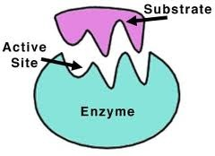

Enzymes are the stuff of life. No cell would be alive without the action of enzymes. Life in a cell is made possible through the hundreds of chemical reactions that occur there. If these chemical reactions proceed too slowly, the activities of the cell would come to a screeching halt. You see, enzymes are biological catalysts. They speed up the chemical reactions of the cell. Without these enzymes, the reactions of the cell would proceed so slowly that they would be of no use to the cell, and the cell would die. Enzymes are involved in every single biological process.
- Enzymes are biological catalysts that speed up the chemical reactions of the cell.
- Enzymes are proteins.
- Enzymatic reactions occur faster and at lower temperatures because enzymes lower the activation energy for that chemical reaction.
- Enzymes are never consumed or used up during the reaction. They can do their job over and over again.
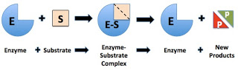
- Enzymes are highly specific for just one substrate. The enzyme has an active site with a unique 3-D shape into which this substrate must fit.
- Enzymes catalyze both the forward and the reverse of the same reaction.
- Enzymes can be denatured by temperatures and pH levels outside the optimal range for that particular enzyme.
Enzymes are truly amazing proteins that play a vital role inside every living cell.

